**Pre-Requisites:**

* Supported OS RHEL 7.9
* DNS Name
* SSL (Chain Files)
  + PEM Key required at the time of installation of fabric and should be placed on Master node
* Database (MySQL 5.7)(10.175.109.131)
* Install Open JDK 11
* NTP should be enabled on all servers
* Swap should be off on all Cluster servers
* Download and Place Quantum Fabric Installer (Container On-prem) on (10.175.109.128-130)

**Architecture:**

d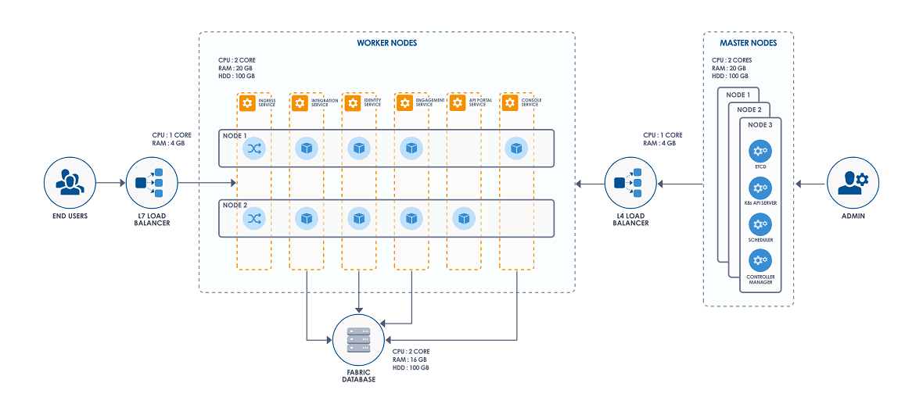

|  |  |  |
| --- | --- | --- |
| Server IP | Hostname | Role |
| 10.175.109.128 | temenosdevapp01 | HA Proxy |
| 10.175.109.129 | temenosdevapp02 | Kubernetes Master |
| 10.175.109.130 | temenosdevapp03 | Kubernetes Slave |
| 10.175.109.131 | temenosdevdb01 | MySQL DB |
| 10.175.109.132 | temenosdevdb02 | Postgres NoSQL |
| 10.175.109.133 | temenosdevdb03 | PAM + KeyCloak + KIEServer |
| 10.175.109.134 | temenosworkshop01 | Microservices |
| 10.175.109.135 | temenosworkshop02 | Microservices |
| 10.175.109.136 | temenosworkshop03 | DES (Data Event Stream - Kafka) |

**Installation:**

**HOST File Configuration: (/etc/hosts)**

1. **10.175.109.128 :**

**10.175.109.128 temenosdevapp01**

**10.175.109.129 temenosdevapp02**

**10.175.109.130 temenosdevapp03**

1. **10.175.109.129 :**

**10.175.109.128 temenosdevapp01**

**10.175.109.129 temenosdevapp02**

**10.175.109.130 temenosdevapp03**

**10.175.109.131 temenosdevdb01**

**10.175.109.128 digital.ndctech.digital**

1. **10.175.109.130 :**

**10.175.109.128 temenosdevapp01**

**10.175.109.129 temenosdevapp02**

**10.175.109.130 temenosdevapp03**

**10.175.109.131 temenosdevdb01**

**10.175.109.128 digital.ndctech.digital**

**Execute Following commands on 10.175.109.128 :**

* Goto /etc/sysconfig/network and append it with “ HOSTNAME=temenosdevapp02 ”
* Execute “ systemctl restart network.service ”
* Unzip Kony Fabric Installer Folder and cd into it
* Execute “ ./setup-loadbalancer.sh ”
  + initial control-plane hostname= temenosdevapp02
  + communication-protocol= 2 (https)
* Execute “ setsebool -P haproxy_connect_any=1 ”
* Execute “ systemctl status haproxy ” (to check status of haproxy)

**Execute Following commands on 10.175.109.129 :**

* Goto /etc/sysconfig/network and append it with “ HOSTNAME=temenosdevapp03 ”
* Execute “ systemctl restart network.service ”
* Unzip Kony Fabric Installer Folder and cd into it
* “ cp config.properties config.properties.bkp ”
  + Backup of configuration File
* Edit config.properties file
  + Variables and their values:
  + (Line no = 4) INSTALL_ENV_NAME=dev (any name you want to give (dev etc))
  + (Line no = 25) SERVER_DOMAIN_NAME=digital.ndctech.digital (your domain name)
  + (Line no = 29) COM_PROTOCOL=https (Your Protocolo http/https)
  + (Line no = 32) HTTPS_CERT_FILE= (path of your .crt files)
  + (Line no = 33) HTTPS_KEY_FILE= (path of your.key files)(you will have your cert files placed on server)
  + (Line no = 43) DB_TYPE=mysql
  + (Line no = 46) DB_HOST=(Host name or ip of your DB)
  + (Line no = 49) DB_PORT=3306(as it is mysql)
  + (Line no = 52) DB_USER=sysdba
  + (Line no = 56) DB_PASS='<Password>'
  + (Line no = 63 & 66)DB_PREFIX & DB_SUFFIX (optional)
  + (Line no = 139) TIME_ZONE=UTC+05:00
* **Making pem file for ssl**
  + “ touch ndctechcert.pem ”
  + copy content of (STAR_ndctech_digital.crt) parameters into pem file created above and save
  + copy content of (SectigoRSADomainValidationSecureServerCA.crt) and append into above pem file
  + copy content of (USERTrustRSAAAACA.crt) and append into above pem file
  + go in key file folder and rename “ cp ndctech.digital.key ndctech.digital.pem ” give path of this file in config.properties (line no 33)
* Execute “ ./install-fabric.sh config.properties ” in Kony Installer Folder to install.

**Wait till it says**

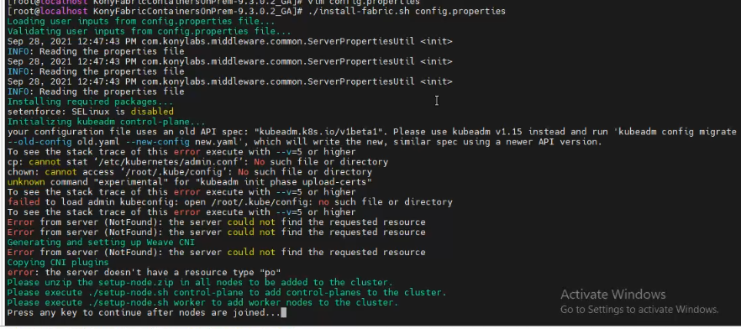

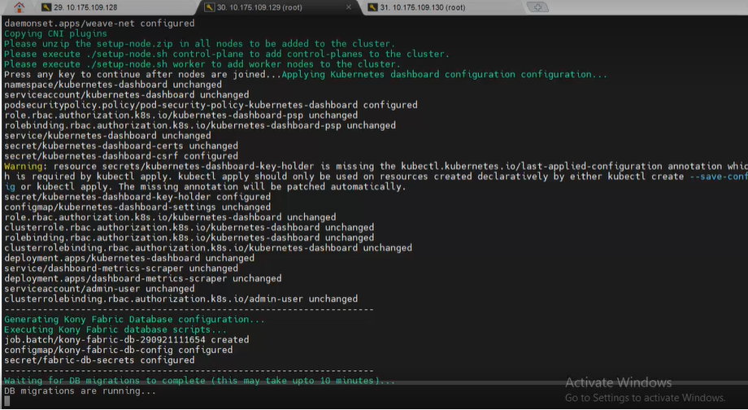

**Execute Following commands on 10.175.109.130 :**

* Goto /etc/sysconfig/network and append it with “ HOSTNAME=temenosdevapp03 ”
* Execute “ systemctl restart network.service ”
* Unzip Kony Fabric Installer Folder and cd into it
* Locate setup-node.zip in konyfabric folder ( unzip setup-node.zip -d setup-node)
* Execute “ cd /proc/sys/net/ipv4/ && echo 1 > ip_forward ”
* run ./setup-node.sh

**Execute Following commands on 10.175.109.129 :**

* Open new terminal and execute “ ./setup-node.sh control-plane ”
* And than go back to previous folder and press any key
* Execute “ kubeadm reset –f ”

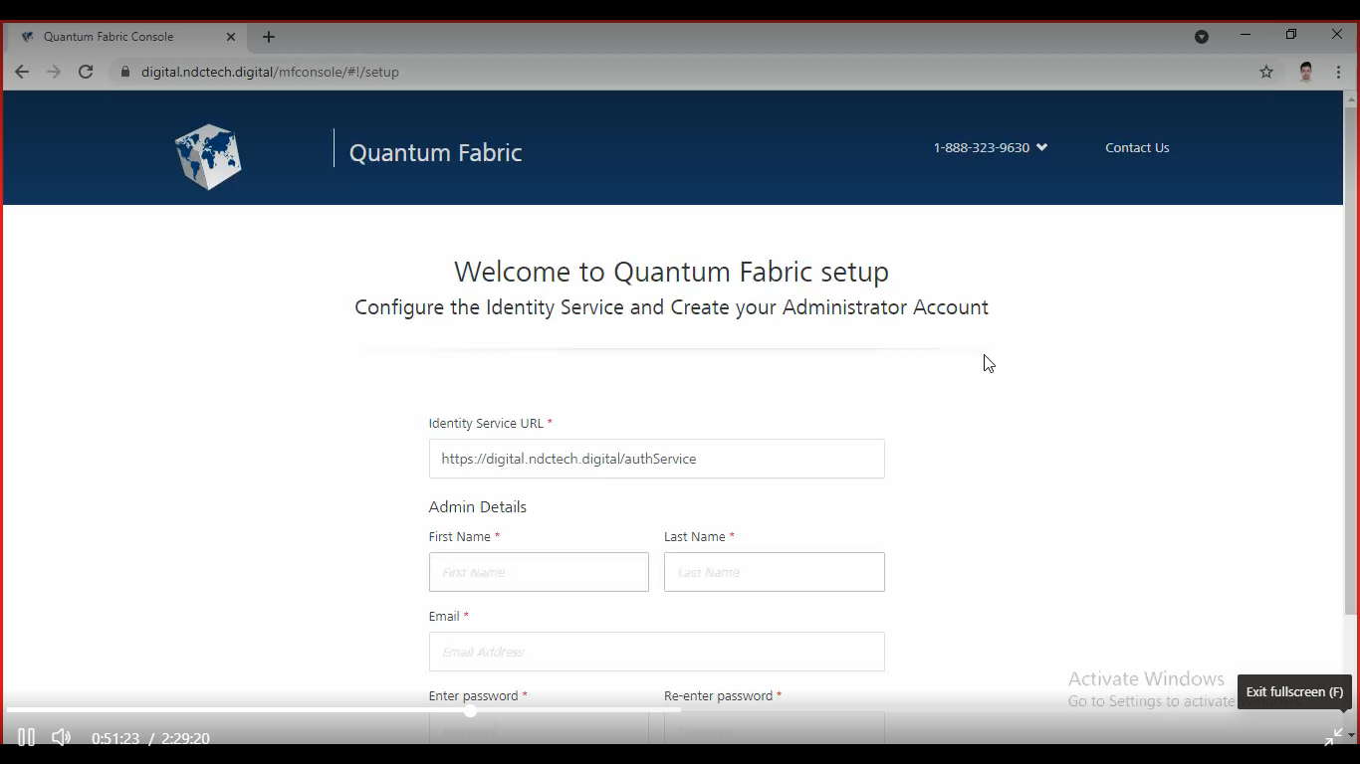

**Health Checks :**

Execute following lines on your browser:

* <https://digital.ndctech.digital/mfconsole/health_check/all>
* <https://digital.ndctech.digital/accounts/health_check/>
* <https://digital.ndctech.digital/kpns/service/healthcheck/json>
* <https://digital.ndctech.digital/authService>
* <https://digital.ndctech.digital/admin/healthcheck>
* <https://digital.ndctech.digital/services/version.html>

**Some Useful Commands:**

|  |  |
| --- | --- |
| COMMAND | ACTION |
| kubectl get pods | Get the list of all the Fabric pods. |
| kubectl get pods --all-namespaces | Get the list of all pods in the cluster. |
| kubectl get nodes | Get the list of all the nodes. |
| kubectl describe po/<POD_NAME> -n <NAMESPACE> | Shows the details of a specific pod. |
| kubectl exec -it <POD_NAME> -n <NAMESPACE> bash | Bash into the container. |
| kubectl logs -f <POD_NAME> -n <NAMESPACE> | View logs of the container. |
| kubectl get services --all-namespaces | Get the list of services in cluster. |
| kubectl delete pod <POD_NAME> - n <NAMESPACE> | Delete a pod. |
| kubectl delete namespaces <NAMESPACE_NAME> | Delete a namespace. |
| ubectl get pod --all-namespaces -o=custom-columns=NAME:.metadata.name,STATUS:.status.phase,NODE:.spec.nodeName | Know which pods are running on which nodes. |
| sudo iptables-save | grep kony-fabric-apiportal | Get the rules created in the IP tables by kubeproxy. |